Company Info :

"Tired with your known professionals and their over pricing. Search variety in your locality at best prices!!!" ApNEEDS is a platform that will cater to all the day to day needs of a commoner. Be it your requirement for an Electrician, Plumber, Carpenter, Driver,Architect or a Smart Home. We will connect you to your local professionals and deliver your needs at your doorstep.

Weekly Overview Of Internship Activities

Week 1 :

- Programmable Logic Control(PLC) Introduction
- History of PLC
- Global Players

Week 2 :

- PLC System

Week 3 :

- Components of PLC
- Working of each components

Week 4 :

- Programming In a PLC
- Ladder Logic Programming

Week 5 :

- PLC Advantages
- PLC Disadvantages

Week 6 :

- PLC Applications
- Brief Analysis

PROGRAMMABLE LOGIC CONTROL(PLC)

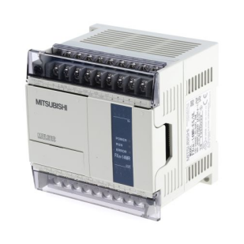  Mitsubishi PLC | 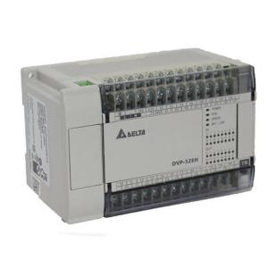  Delta DVP-EH3 PLC | 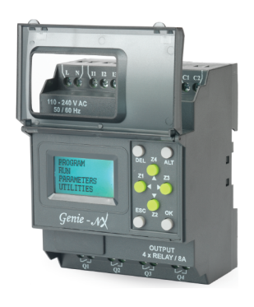  PLC VERSION 6 | 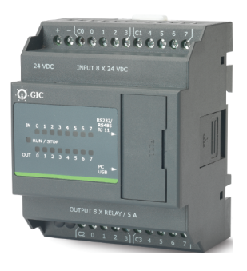  MINI PLC PL –100

➤ A Programmable Logic Controller (PLC) is a specialized computing system used for control of industrial machines and processes.

➤A PLC is a micro processor based solid state / computerized industrial computer that performs discrete or sequential logic in a factory environment.

➤It was originally developed to replace mechanical relays, timers, and counters.

➤PLCs are used successfully to execute complicated control operations in a plant.

➤A PLC is a computer designed to work in an industrial environment.

➤It uses a programmable memory to store the instructions and specific functions that include On/Off control, timing counting, sequencing, arithmetic and data handling.

➤PLCs are equipped with a special input/output interface

History of PLC

➤The PLC was invented in response to the needs of the American automotive manufacturing industry. Programmable logic controllers were initially adopted by the automotive industry where software revision replaced the re-wiring of hard-wired control panels when production models changed.

➤In 1968 GM Hydramatic (the automatic transmission division of General Motors) issued a request for proposal for an electronic replacement for hard-wired relay systems. The winning proposal came from Bedford Associates of Bedford, Massachusetts.

➤The first PLC, designated the 084 because it was Bedford Associates' eighty-fourth project, was the result. Bedford Associates started a new company dedicated to developing, manufacturing, selling, and servicing this new product: Modicon, which stood for Modular Digital Controller. One of the people who worked on that project was Dick Morley, who is considered to be the "father" of the PL

Global Player

1. Siemens | 2. Allen Bradley
3. Mitsubishi | 4. GE
5. ABB | 6. Delta
7. Yokogawa | 8. Omran
9. National Instrument | 10. Schneider Electric
11. Honeywell

COMPONENTS OF PLC

- Processor  - Memory Unit  - Power Supply  - I/O Modules | 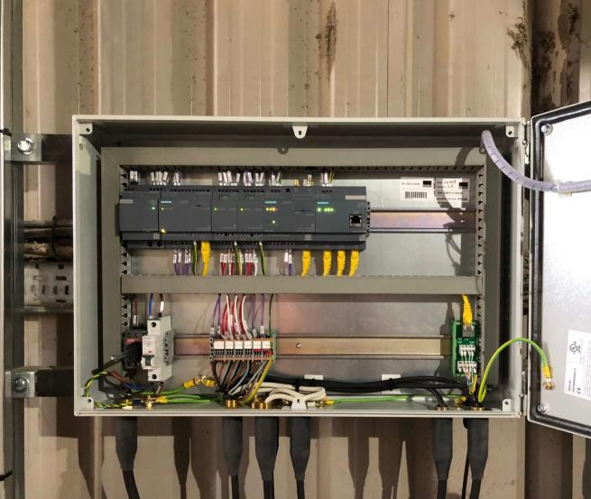

PLC System

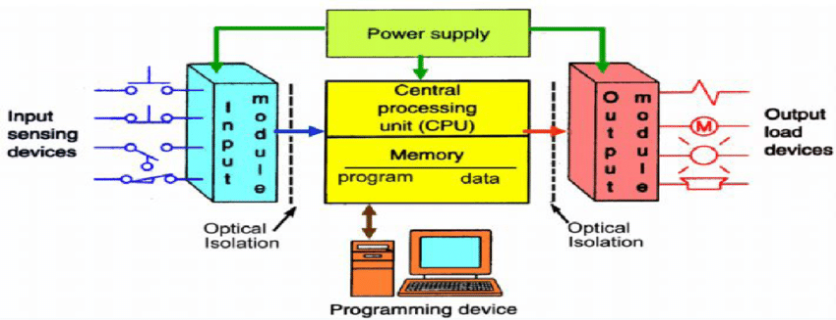

Programmable logic controllers are a flexible and robust control solution, adaptable to almost any application.

1. Processor :

➤Processor is the central processing unit (CPU) of the programmable controller; it executes the various logic and sequencing functions by operating on the PLC inputs to determine the appropriate output signals.

➤The CPU consists of one or more microprocessors similar to that of PCs and other data processing equipment but are designed to facilitate I/O transactions with different ranges with corresponding clock speed.

➤ Consists of a microprocessor for implementing the logic and controlling the communications among the modulus.  ➤ Designed, so the desired circuit can be entered in relay ladder logic form.  ➤ The processor accepts the input data from various sensing devices, executes the stored user program and sends appropriate output commands to control devices. | 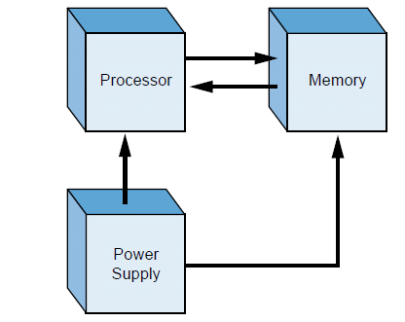  - PLC CPU Architecture
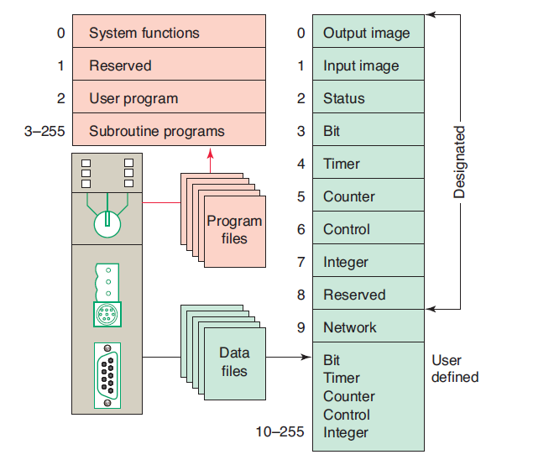PLC Processor Memory Organization

2. Memory :

➤ Memory unit is connected to the CPU, which contains the programs of logic, sequencing and I/O operations .

➤ It also holds data files associated with these programs, including I/O stations bits, counter and timer constants, and other variable and parameter values.

➤ This memory unit is referred to as the user or application memory because its contents are entered by the user and also directs the execution of control programs and coordinates I/O operations with the aid of system memory.

3. Power Supply:

➤ A power supply of 120v alternating current(ac) is typically used to drive the PLC (some units operate on 240 v ac).

➤ The power supply converts the 120v ac into direct current (de) voltages of
( 土 )5V.

➤ These low voltages are used to operate equipment that may have much higher voltage and power ratings than the PLC itself.

➤ The power supply often includes a battery backup that switches in automatically in the event of an external power source failure.

➤ Supplies DC power to other modules that plug into the rack.  ➤ In large PLC systems, this power supply doesn't normally supply power to the field devices.  ➤ In small and micro PLC systems, the power supply is also used to power field devices. | 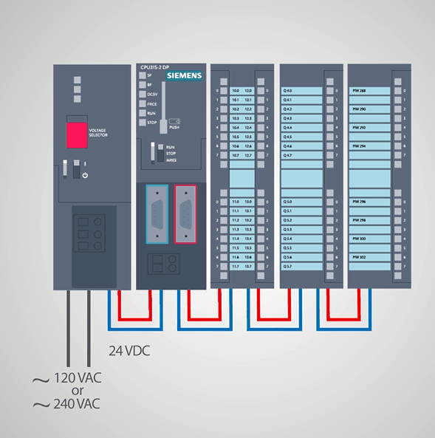

4. I/O Modulus:

➤ The input/output module provides the connections to the industrial equipment or process that is not to be controlled.

➤ Inputs to the controller are signals from limit-switches , pushbuttons, sensors, and other on/off devices.

➤ Outputs from the controller are on/off signals to operate motors, valves, and other devices required to actuate the process.

➤ Many PLCs are capable of accepting continuous signals from analog sensors and generating signals suitable for analog actuators.

➤ Forms the interface by which input field devices are connected to the controller.

➤ The terms “field” and “real world” are used to distinguish actual external devices that exist and must be physically wired into the system.

➤ Forms the interface by which output field devices are connected to the controller.

➤ PLCs employ an optical isolator which uses light to electrically isolate the internal components from the input and output terminals.

5. Programming Device :

➤ The PLC is programmed by means of a programming device. The programming device is usually detachable from the PLC cabinet so that it can be shared among different controllers.

➤ Different PLC manufacturers provide different devices , ranging from simple teach pendant type devices , similar to those used in robotics, to special PLC programming keyboards and CRT displays.

➤ PCs and laptops now widely used for programming are much faster and a PC / laptops are also smaller now.

➤ The software allows users to create, edit,document, store and troubleshoot programs .

➤ The personal computer communicates with the plc processor via serial or parallel data communications link

➤ U Hand – held programming devices are sometimes used to program small PLCs.

➤ They are compact, inexpensive and easy to use, but are not able to display as much logic on screen as a computer monitor.

➤ Hand-held units are often used on the factory floor for troubleshooting, modifying programs and transferring programs to multiple machines.

Programming In a PLC

Users have multiple choices for programming a PLC.

Ladder Logic | Functional Block Diagram | Statement List
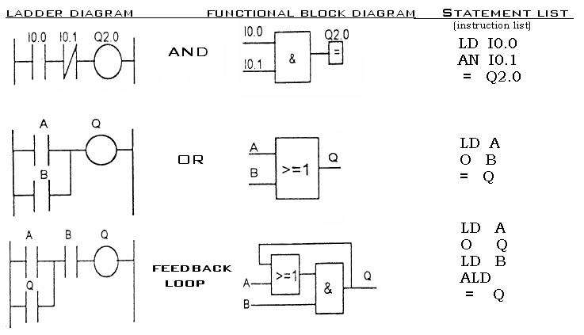

Ladder Logic Programming

It is an easy way of programming the PLC. So that Engineer must be concerned only on procedure and functionality of the machinery design.

For this knowledge of basic Electronics Circuit is sufficient .

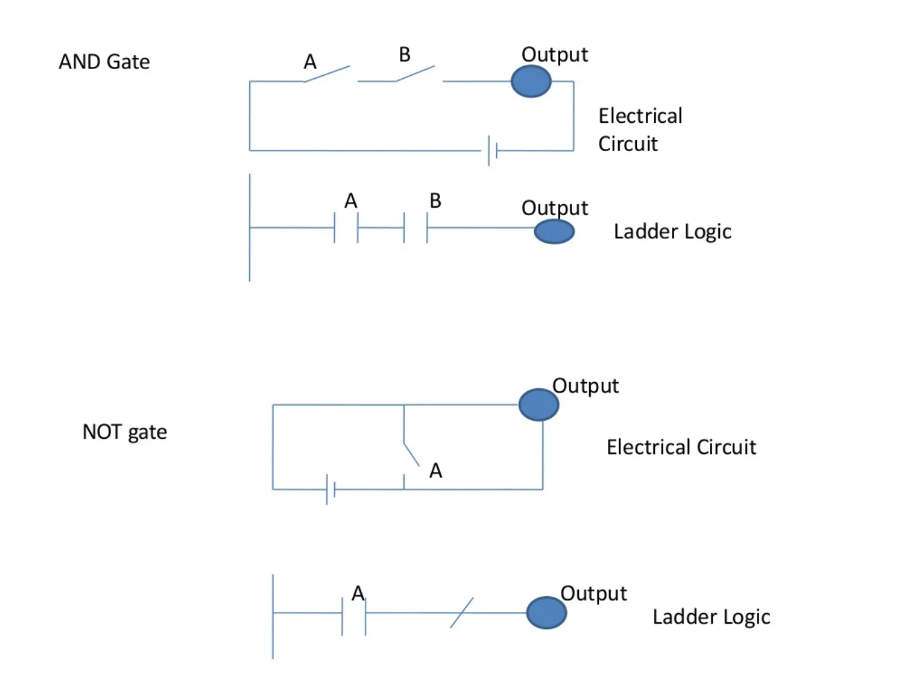

PLC ADVANTAGES

- Less and simple wiring.
- Increased Reliability.
- More Flexibility/Modular.
- Lower Cost.
- Faster Response.
- Easier to troubleshoot.
- Remote control capability.
- Communication Capability.

- Handles much more complicated systems & Complex operations can be performed easily.

- Multiple devices such as timers, memory shells, etc. are embedded in one system which makes PLC very convenient and versatile to use

PLC DISADVANTAGES

- There's too much work required in connecting wires. A lot of hard wiring is required for connection of input and output devices.

- It is difficult to find errors.
- Skillful workers are required.
- There's difficulty with replacements.
- Initial cost of PLC is high

- PLC devices are proprietary, which means that parts and software from one manufacturer can't easily be used in combination with parts of another manufacturer, which limits the design and cost options.

- Since PLC is a semiconductor device, it can’t be operated over a level of temperature where it can’t sustain it.

PLC APPLICATIONS

➤ PLCs are generally used in industries for controlling heavy machinery and processes like conveyor systems, CNC machines etc.

➤ PLC usage can also be observed in day to day life. For eg : automatic washing machines, cars, video cameras etc.

➤ PLC has it's applications in almost every automatic machine.

- Air compressors
- Airport runway lighting control
- Traffic signal control
- Smoke alarm control
- Textile equipments
- Vacuum pump system

➤ Apart from these applications, PLC is widely used in the automation of electrical power systems. At electrical substations automatic reclosing, circuit breaker tripping, capacitor switching, etc. can be controlled with PLCs

CONCLUSION

On the whole, this internship was a useful experience. I have gained new knowledge, skills and met many new people. I achieved several of my learning goals.

| got insight into professional practice. I learned the different facets of working within a company. I learnt a lot and hope the learning will help me shape my future career.

The Internship was also good to find out my strengths and weaknesses. This helped me to define what skills and knowledge I have to improve in the coming time.

At last this internship has given me new insights and motivation to pursue a career in electronics/electrical.

